**CTS DIGITAL NURTURE - 4.0 JAVA FSE**

**WEEK 8 - GIT**

**2.Git HOL2**

**Create a “.log” file and a log folder in the working directory of Git. Update the .gitignore file in such a way that on committing, these files (.log extensions and log folders) are ignored.**

**Verify if the git status reflects the same about working directory, local repository and git repository.**

**Creating log file and folder**

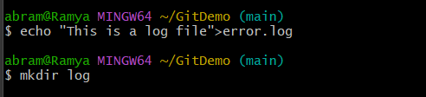

**Update and Add .gitignore**



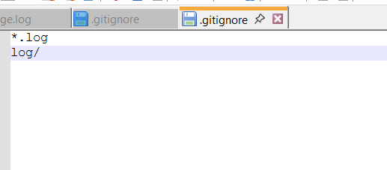

**Before updating, git status**

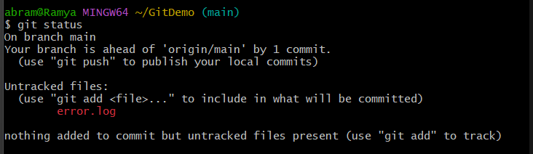

**After updating, git status**

